Week 2 Exercise
Objective 1. Conceptual Foundations
This week’s exercise focuses on HDFS (Hadoop Distributed File System), YARN, and MapReduce, which are core components of the Hadoop ecosystem. Together, these tools form the foundation of Hadoop’s distributed architecture and demonstrate how large-scale data can be stored, accessed, and processed using industry-standard practices. Hadoop is designed to handle petabytes of data efficiently by distributing both storage and computation across many machines, allowing organizations to scale while maintaining reliability and performance.
HDFS serves as the storage layer of the Hadoop architecture. Instead of storing data on a single system, HDFS breaks large files into blocks and distributes them across multiple DataNodes in the cluster. Each block is replicated across several nodes, providing built-in fault tolerance and ensuring data availability even if a node fails. This design allows Hadoop to store massive datasets reliably while also enabling faster data access by moving computation closer to where the data resides.
YARN, which stands for Yet Another Resource Negotiator, is responsible for resource management and job scheduling within the Hadoop cluster. Similar in concept to hypervisors or virtualization platforms like VMware, YARN allocates memory and CPU resources by managing containers and Application Masters across nodes. Because cluster resources are limited, YARN plays a critical role in prioritizing workloads, balancing resource usage, and ensuring that applications run efficiently and reliably without overwhelming the system.
MapReduce is the original distributed processing model used by Hadoop to analyze large datasets in parallel. Data is divided into input splits, which are processed by Map tasks that generate intermediate key-value pairs. These results are then shuffled and sorted before being passed to Reduce tasks, which aggregate and produce the final output. This model demonstrates how large-scale computations can be performed efficiently by distributing work across multiple nodes in the cluster.
Objective 2. Deep Dive into HDFS
This week’s exercise focuses on HDFS and its interaction with the Hadoop ecosystem. We began by running the hdfs dfsadmin -report command, which provides a detailed overview of the HDFS cluster’s current state. This report includes information about the health of the cluster, available storage capacity, and the status of each DataNode. Reviewing this output is an important first step in understanding how data is distributed and managed across the cluster.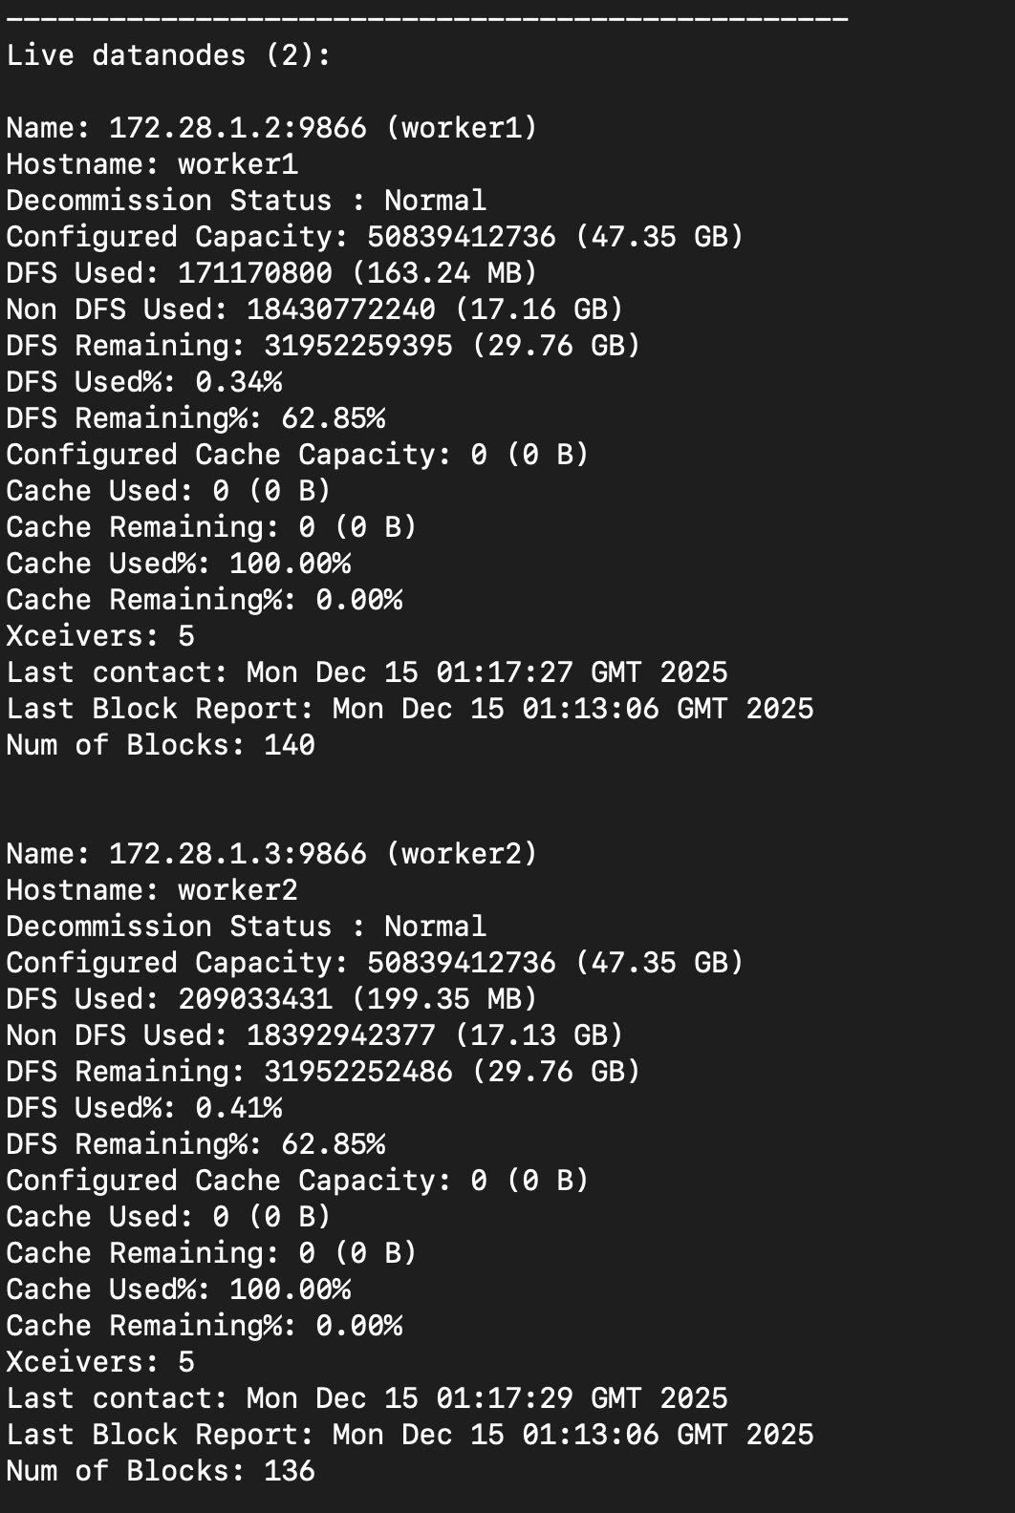
To demonstrate HDFS storage, we uploaded grades.csv into the HDFS root directory using hdfs dfs -put. HDFS stores the file as one or more blocks on DataNodes and replicates those blocks based on the cluster’s replication factor. We can verify which DataNodes hold the blocks using HDFS tools (such as fsck), rather than expecting to find a normal ‘grades.csv’ file on each worker’s local filesystem.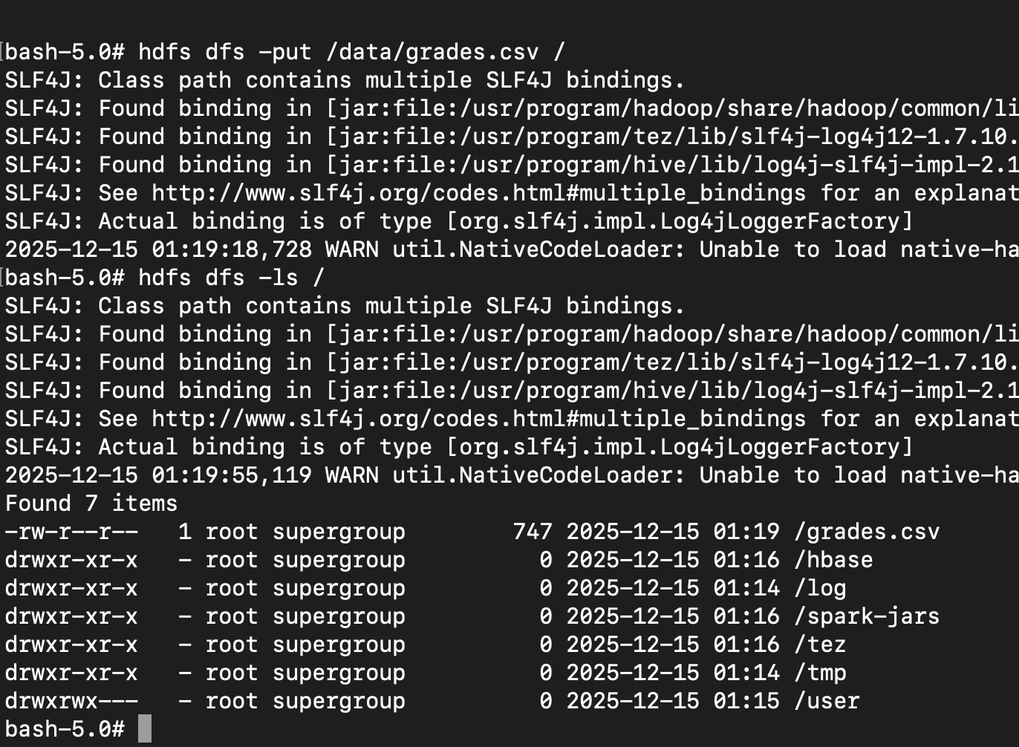
docker compose exec worker1/worker2 bash opens a shell inside each worker container, but hdfs dfs -ls / always shows the same output because it lists the shared HDFS namespace managed by the NameNode, not the local filesystem. This confirms the file exists in HDFS and is visible cluster-wide, though it does not indicate which workers physically store the file’s data blocks.
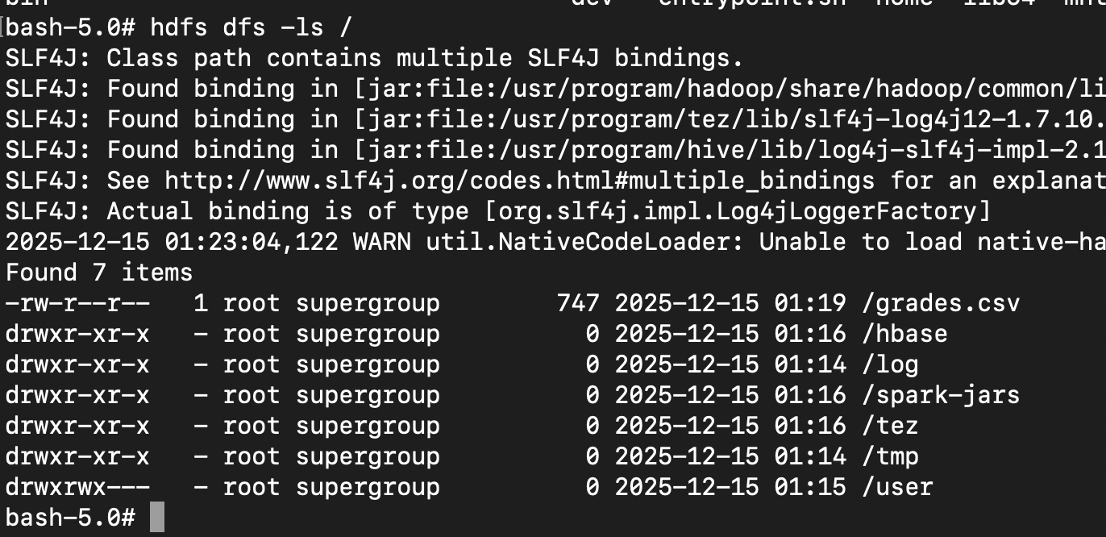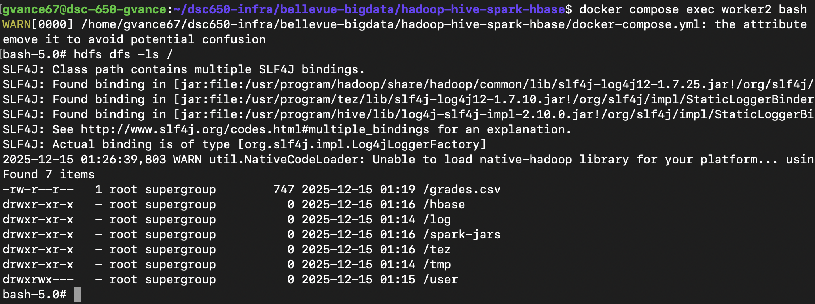
The df -h command reports disk usage and available capacity in a human-readable format, allowing us to understand how much storage space is used and remaining across the filesystem.
The fsck command performs a filesystem check on HDFS and reports detailed information about file health, including block locations, replication status, and whether any blocks are missing or corrupted.
The getfacl command displays the access control lists for files and directories, showing detailed permission rules such as read, write, and execute access for users and groups.
Command 1 - df -h 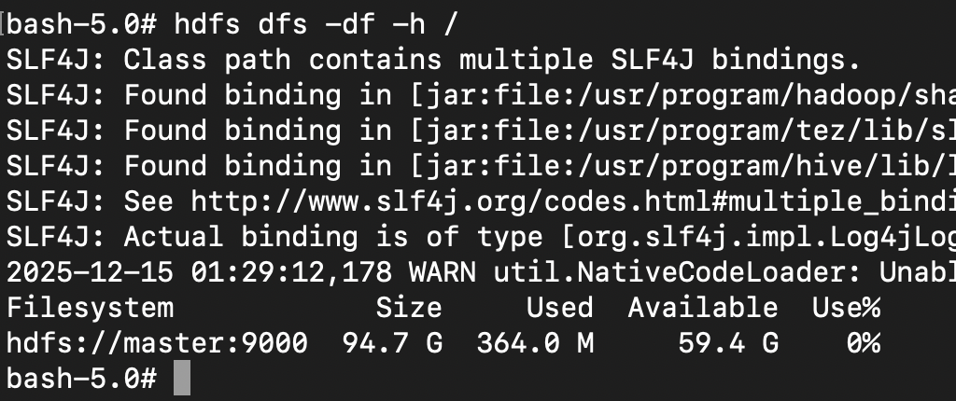

Command 2 - fsck
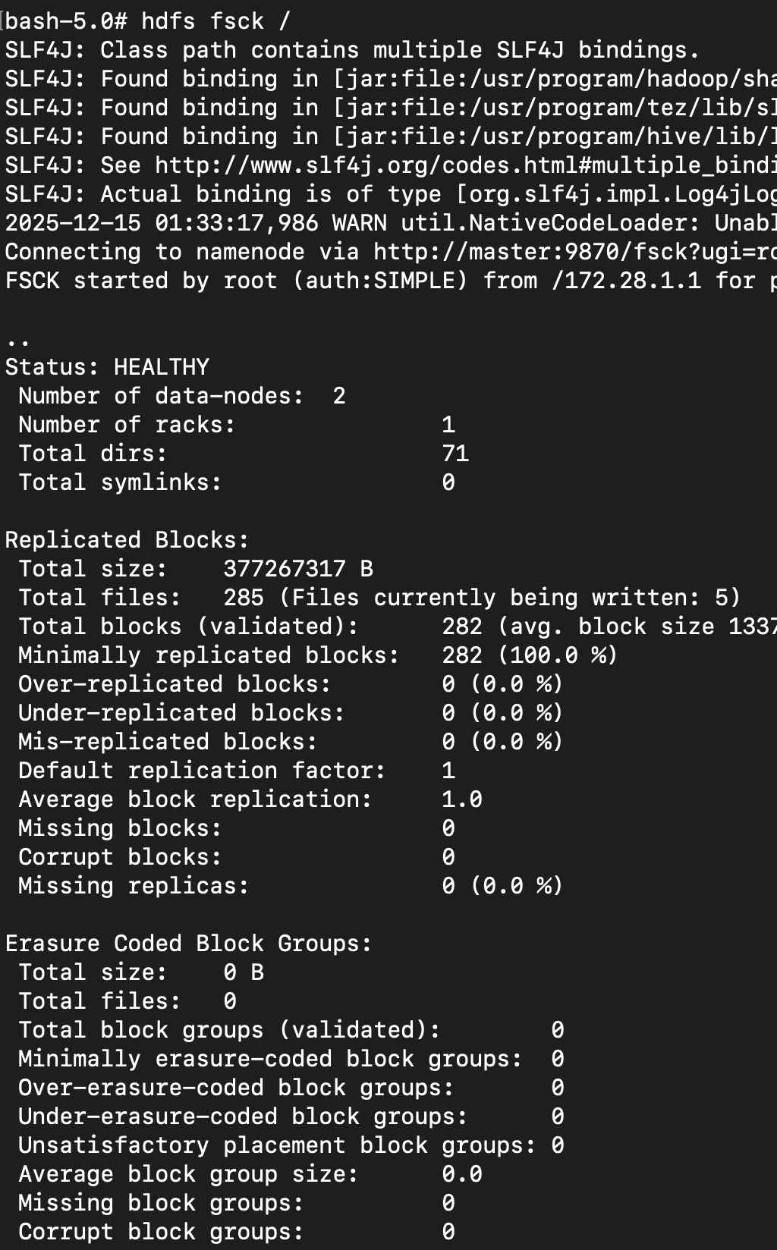

Command 3 – getfacl
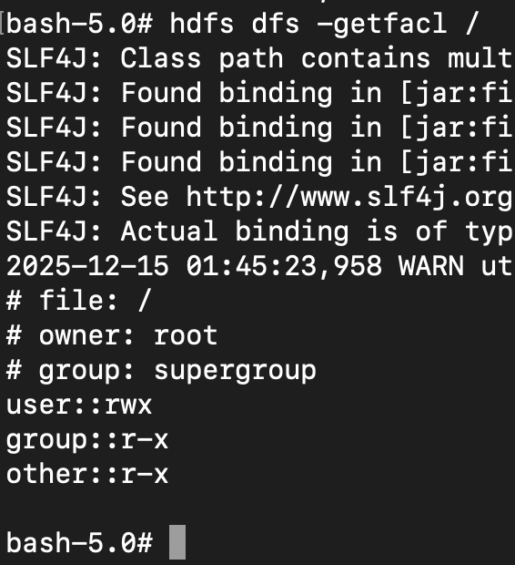
Objective 3 – Introduction to YARN
This command lists all YARN NodeManagers in the cluster and shows that two worker nodes are currently registered and running. The output also indicates that no containers are actively running on either node at the time of execution, meaning no YARN jobs are consuming resources.
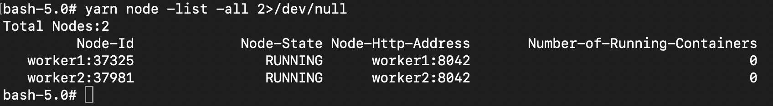
Within the etc/hadoop configuration directory, we have access to several Hadoop configuration files that control cluster behavior. Since the YARN ResourceManager application is running on port 8088, we can modify the memory-related settings to increase allocations to 2048 MB, and after applying the changes and refreshing the web interface, the updated memory values are reflected.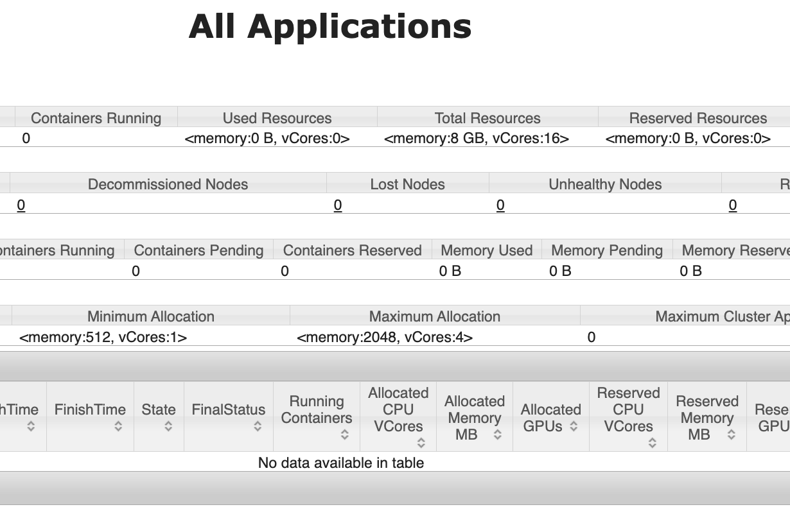
Objective 4. MapReduce Pi Job
The MapReduce Pi example uses a Monte Carlo simulation to estimate the value of π by randomly generating points within a square and counting how many fall inside a unit circle. Each map task independently performs this random sampling and reports its results, while the reduce task aggregates the counts across all maps to calculate the final approximation of π. This example illustrates how Hadoop can distribute probabilistic computations across multiple nodes and combine the results efficiently using MapReduce.

